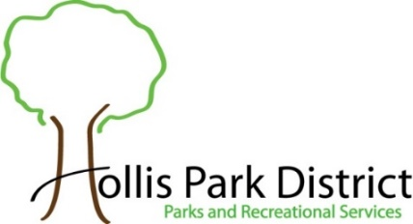
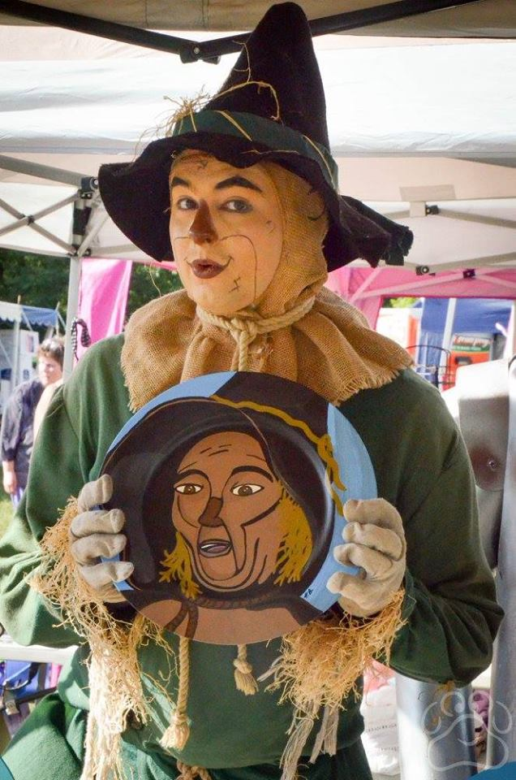
2022 Oz Fest
Vendor Application

When: Saturday, August 13, 2022
Time: 10am to 6pm
Booth Size: 12’ x 12’
Cost: $45.00 by June 30th $55.00 after June 30th

- Please No Food Vendors
- Booth must be open during the Festival.
- No Electrical Service Provided. Park will open at 6:30am for vendors to set up their booth.
- The Hollis Park District has the right to reject and remove objectionable items at their discretion.
- Vendor is 100% responsible for the security of their booth, its contents and for the cleanup of their area.
- Send and make checks payable to : Hollis Park District 9424 S. Mapleton Road Mapleton, IL 61547
- Acceptance is not guaranteed until the vendor has received a confirmation email from Oz Fest.
- Fee is nonrefundable once accepted.
- The list of the vendors will be updated weekly on the www.hollispark.org under Special Events, Oz Fest.
- Maximum of 50 spots available. First come, first serve basis.
- There is an Entrance Fee to visitors: $5 Adult; $3 for Senior (55+) & Children 3-12yrs and 2 under Free.
- If we have inclement weather, no cars will be allowed on the grass. Please bring carts to unload & load your booth.

Booth’s Business Name Vendor’s Last Name First Name

Address City State Zip

Primary Phone Cell Phone Email Address

Check if you are interested in receiving e-mail notifications Yes for Text Messages Carrier:

Description of booth and the items that will be sold: ____________________________________________________________
_________________________________________________________________________________________________

Consideration for Special Needs/Requests: _________________________________________________________________
_________________________________________________________________________________________________

Waiver/Release:
I agree to hold Hollis Park District, and its officers, directors, employees and agents harmless from any losses and damages to myself resulting from participation in these activities. I hereby grant permission for pictures and/or videos to be taken of myself during this program for future promotional use for no consideration. My signature below confirms that I have read and agree with this application and the waiver/release.

Vendor Signature: ____________________________________________ Date:
For HPD
Office Use Only
Date Received: Receipt #: Cash Check #_______ Charge #_______
Paid $ HPD Initials:

Emailed Sent: HPD Initials: Booth # Assigned:

Hollis Park District 9424 S. Mapleton Road Mapleton, IL 61547 Phone: 309-697-2944 press 1
HPD Website: www.hollispark.org Facebook: Oz Festival Illinois

